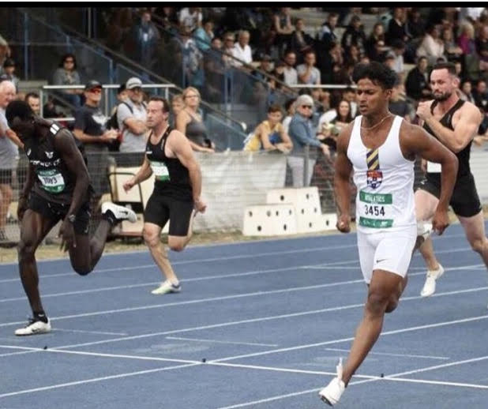

Coach Profile
Nabill became a coach 2 years ago out of his passion for all things fast. It was an opportunity for him to share his love of speed with other people and improve on his personal athletic ability.

The world of speed and sprinting, is a place where athletes not only enjoy the feeling of flying on track but it’s also a place where athletes can learn about who they are and how capable they can be both on and off the track.

He wants to be the ‘bridge’ for athletes to discover new limits and go beyond them.

He currently coach privately full time and then run two other businesses in tech!

Coach Achievements
- Coached 2 x U12 School Sport Australia athletes to achieving medals at their national competitions
- Coached 12 athletes at a state level for athletics
- Coached 2 athletes who went on to sign a contract into a professional NRL team for first grade
- Assisted with coaching of multiple current and former professional NRL players with their speed
- Handled Athletic Development at Cranbrook Junior School
- Delivered Speed Education Seminars around Australia
- Contributed to PhD research in sprinter injury prevention and rehabilitation

Personal Achievements
- Represented Australia at the 2017 Oceania Games Championship
- Gold and Silver Medallist at the 2017 Oceania Games Championship
- Top 100 all-time U18 100m Sprinters
- Ranked 52 in the world for the 100M in 2020
- 4 Time National Medallist
- 5 Time State Medallist

